Advance Statistics Project Report
Submitted By: Deepti Agrawal
Date of Submission: February 28, 2021
Please refer to AS_Project_DeeptiAgrawal (Jupyter file) for the code.

Problem 1:
Salary is hypothesized to depend on educational qualification and occupation. To understand the dependency, the salaries of 40 individuals [SalaryData.csv] are collected and each person’s educational qualification and occupation are noted. Educational qualification is at three levels, High school graduate, Bachelor, and Doctorate. Occupation is at four levels, Administrative and clerical, Sales, Professional or specialty, and Executive or managerial. A different number of observations are in each level of education – occupation combination.
[Assume that the data follows a normal distribution. In reality, the normality assumption may not always hold if the sample size is small.]
Performing basic Exploratory Data Analysis on the dataset
Checking the structure of SalaryData.csv by viewing the top 5 rows (head).
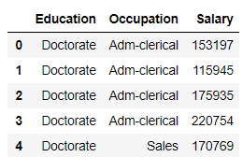
The dataset consists of 3 variables/attributes.
Education- Showing the level of education out of 3 levels: High School graduate, Bachelor or Doctorate.
Occupation- Type of occupation is from 4 levels: Administrative and clerical, Sales, Professional or specialty, and Executive or managerial.
Salary- Salary of the individual
Also, dataset has 40 instances of such individuals.
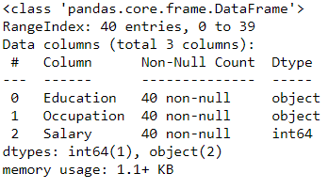
Education and Occupation are categorical variables whereas Salary is of integer type.
Also, there are no null/missing value in the dataset.

Data Statistics/Summary:
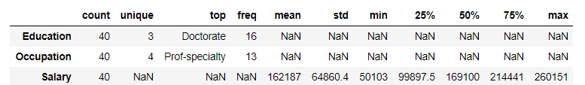
The minimum salary offered is 50103 and it goes up to maximum 260151
The average salary is 162187
There are 3 unique education levels and 4 unique Occupations.
Plotting the count of unique education and occupation levels.
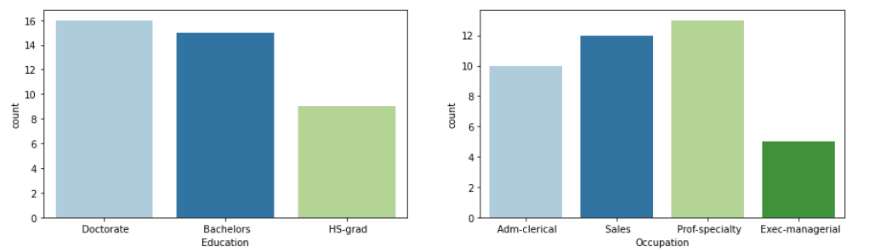
Box Plot of Education and Occupations with respect to salary.
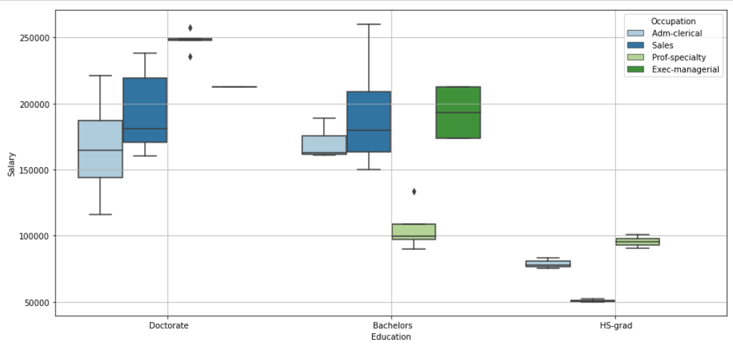
This shows that High school graduates are offered very less salaries.
Also, Sales professionals are paid more salary than professionals from other occupations.
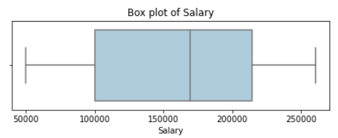
Here from the boxplot of Salary variable, we can observe that it has no outliers and it seems to be left skewed.
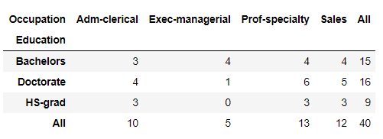
The above table shows the count of Individuals with respect to particular education and corresponding occupation.
This also shows that high school graduates do not take up or have very less opportunities into executive or managerial professions.
The main aim of this analysis is to check the dependency of individual’s Salary on his Education and Occupation. Thus, we are observing Salaries of 40 individuals on these parameters.
For checking this dependency, we will perform ANOVA or analysis of variance. ANOVA checks the impact of one or more factors by comparing the means of different samples.
Here we will perform ANOVA on Salary with respect to education and occupation individually and also combined (interaction).
Assumptions for performing one-way ANOVA:
- The samples drawn from different populations are independent and random.
- The response variables of all the populations are normally distributed.
- The variance of all the populations are equal.
Here, we are given in the instructions that the dataset qualifies for the assumptions of ANOVA.
Therefore, we can go ahead with performing the analysis on this data.

Q1. State the null and the alternate hypothesis for conducting one-way ANOVA for both Education and Occupation individually.
The technique of ANOVA or Analysis of Variance is used to establish a cause and effect relationship amongst variables. One-way ANOVA is a hypothesis test, used to test the equality of three or more population means simultaneously using variance.
- Formulating the Null and Alternate Hypothesis for conducting One-Way Anova on Salary with respect to Education Levels
Null Hypothesis Ho: The mean Salary for different individuals is same for different Education Levels
Alternate Hypothesis Ha: The mean Salary for different individuals is different for at-least one Education Level
- Formulating the Null and Alternate Hypothesis for conducting One-Way Anova on Salary with respect to Occupation Levels
Null Hypothesis Ho: The mean Salary for different individuals is same for different Occupation Levels
Alternate Hypothesis Ha: The mean Salary for different individuals is different for at-least one Occupation Level

Q2. Perform a one-way ANOVA on Salary with respect to Education. State whether the null hypothesis is accepted or rejected based on the ANOVA results.
Null Hypothesis Ho: The mean Salary for different individuals is same for different Education Levels
Alternate Hypothesis Ha: The mean Salary for different individuals is different for at-least one Education Level
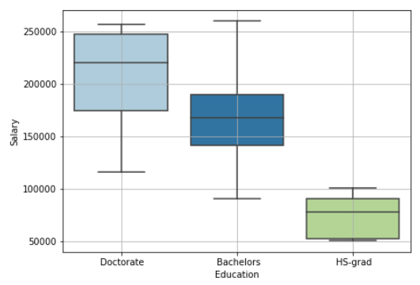
Output of one-way ANOVA on Salary with respect to education levels:
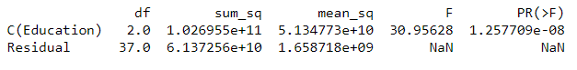
Let us consider the summary output known as ANOVA Table. For the given problem sum of squares due to the factor Education (SSB) is 1.026955e+11 and the sum of squares due to error (SSW) is 6.137256e+10. Since the factor has 3 levels, DF corresponding to Education is 3 – 1 = 2. Total DF is 40 – 1 = 39. Hence DF due to error is 39 – 2 = 37. Mean sum of squares is obtained by dividing the sums of squares by corresponding DF. The value of the Fstatistic is approximately 31 and the p-value is highly significant.
Sum of Squared variance within is the sum over the sums of squared deviations of scores around their group’s mean
Sum of Squared variance between is the sum of squared deviation of the group means from the grand mean.
Sum of Squared Total is equal to 108215412789.24692
F-Distribution or F-Statistic is the ratio of MSB to MSW.
It gives the degree of how relatively greater the difference is 'between group means' (MSB) compared to 'within group variance' (MSW)
If the ratio is greater than expected it mean that not all the group means are the same and at least one mean is substantially different.
p_value =1.257709e-08 is smaller than the level of significance 𝛼 0.05
Based on the ANOVA test observations, it is concluded that we reject the null hypothesis that the three population means are identical.
Therefore, at least for one education level mean Salary is different from the rest. Residuals are defined as the difference between the observed values and the expected values.

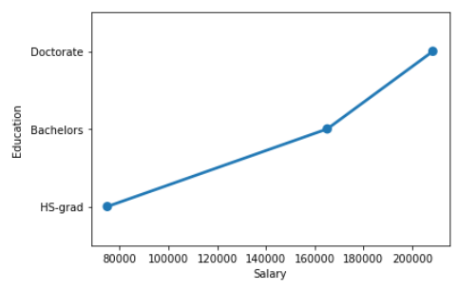
The above graph shows a point plot of Salary with respect to Education.
Q3. Perform a one-way ANOVA on Salary with respect to Occupation. State whether the null hypothesis is accepted or rejected based on the ANOVA results.
Null Hypothesis Ho: The mean Salary for different individuals is same for different Occupation Levels
Alternate Hypothesis Ha: The mean Salary for different individuals is different for at-least one Occupation Level
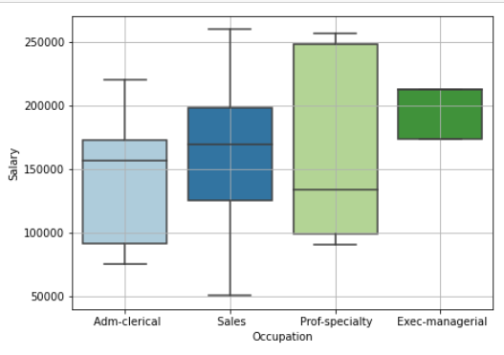
Output of one-way ANOVA on Salary with respect to Occupation levels:
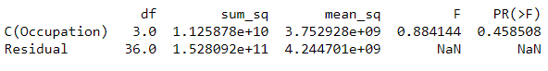
Let us consider the summary output known as ANOVA Table. For the given problem sum of squares due to the factor Occupation (SSB) is 1.125878e+10 and the sum of squares due to error (SSW) is 1.528092e+11. Since the factor has 4 levels, DF corresponding to Occupation is 4 – 1 = 3. Total DF is 40 – 1 = 39. Hence DF due to error is 39 – 3 = 36. Mean sum of squares is obtained by dividing the sums of squares by corresponding DF. The value of the Fstatistic is approximately 0.88 and the p-value is high.
Sum of Squared Total is equal to 164068026010.375
p_value =0.458508 is greater than the level of significance 𝛼 0.05
Based on the ANOVA test observations, it is concluded that we fail to reject the null hypothesis that the three population means are identical.
Therefore, the mean salary is same for all occupation levels.
The below graph shows a point plot of Salary with respect to Occupation.
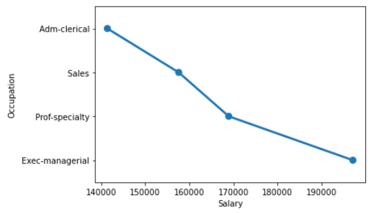

Q4. If the null hypothesis is rejected in either (2) or in (3), find out which class means are significantly different. Interpret the result.
We have rejected the null hypothesis while performing ANOVA on Salary with respect to Education (2) variable.
An ANOVA test can tell us if our results are significant overall, but it won’t tell us exactly where those differences lie. After we have run an ANOVA and found significant results, then we can run Tukey’s HSD to find out which specific group’s means (compared with each other) are different. The test compares all possible pairs of means.
Therefore, performing Tukey Honest Test to check the difference between different education levels.
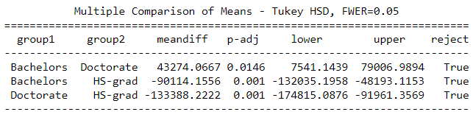
Conclusion: We can see that there is a large difference in the lower and upper limits and the p value is also significant that there is a difference between the means. It shows that there is a visible difference in the mean salaries of all education levels.

Problem 1B:
Q1. What is the interaction between two treatments? Analyze the effects of one variable on the other (Education and Occupation) with the help of an interaction plot. [Hint: use the ‘pointplot’ function from the ‘seaborn’ function]
Interaction is a quantification of association of two factors. If one factor behaves differently at different levels of one or more factors, an interaction effect is said to exist.
Interaction occurs when the pattern of the cell means in one row (going across columns) varies from the patterns of cell means in other rows.
Plotting a box plot to visualize the variations on Salary with respect to both Education and Occupation.
In the above box plot, we can observe that HS-grad are offered the least salaries. Also, people with doctorate degrees are paid the most.
Interaction occurs when the effects of treatment vary according to the levels of treatment of the other effect or in other words it can be defined as the failure of the response to one factor to be the same at different levels of another factor.
InteractionPlots: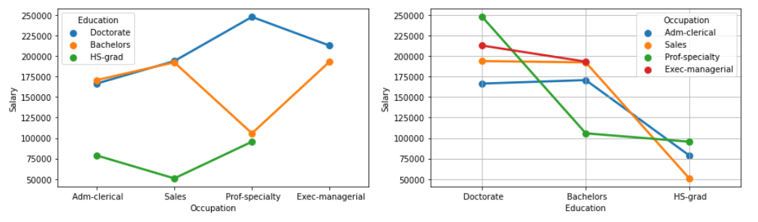
The interaction plot shows that there is an interaction between the factors if some of the line segments are not parallel and intersect at some points.
We have discussed the statistics of the interaction effect in the next question through an ANOVA table.
As we can see in the above pointplot, we observe that there are interactions between Occupation and education.
Q2. Perform a two-way ANOVA based on Salary with respect to both Education and Occupation (along with their interaction Education*Occupation). State the null and alternative hypotheses and state your results. How will you interpret this result?
Two-way ANOVA uses two factors (independent or interacting) to test various hypotheses of interest.
The primary purpose of a two-way ANOVA is to understand if there is an interaction between the two independent variables on the dependent variable.
Here, we are performing two-way ANOVA on salary with respect to education and occupation levels.
Formulating the Null and Alternate Hypothesis for two-way ANOVA on Salary with Education and Occupation:
Null Hypothesis Ho: The mean Salary with respect to each Occupation and Education category is equal.
Alternate Hypothesis Ha: At least one of the means of Salary with respect to each Occupation and Education category is unequal.
Output of two-way ANOVA on Salary with respect to Occupation and Education levels:
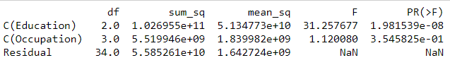
Let us consider the summary output known as ANOVA Table. For the given problem sum of squares due to the factor Education (SSB) is 1.026955e+11 and the sum of squares due to Occupation (SSW) is 5.519946e+09. Since education factor has 3 levels, DF corresponding to education is 3 – 1 = 2. And, occupation factor has 4 levels, DF corresponding to occupation is 4 – 1 = 3. Total DF due to error is 40-(2+3+1) = 34. Mean sum of squares is obtained by dividing the sums of squares by corresponding DF. The value of the Fstatistic is approximately 31.2 for education and 1.12 for occupation.
Also, the p-value is high for occupation and low for education.
Concluding on the above anova table and considering both the factors (education and occupation), education is a significant factor as the p-value is less than 0.05 whereas occupation is not a significant factor as the p-
Formulating the null and alternate hypothesis for interaction between occupation and education.
Null Hypothesis Ho: The interaction effect between education and occupation does not exist.
Alternate Hypothesis Ha: The interaction effect between education and occupation exists.
Output of two-way ANOVA with interaction effect of Education on Occupation:
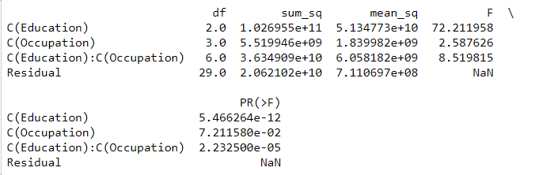
p_value =2.232500e-05 is less than the level of significance 𝛼 0.05
Based on the ANO.VA test observations, it is concluded that we reject the null hypothesis that there is no interaction effect between the two factors.
Therefore, there seems to be some statistical interaction between education and occupation. Hence, education and occupation has a combined effect on the salaries of individuals.

Q3. Explain the business implications of performing ANOVA for this particular case study.
In the above case study, we have analyzed the sample of 40 individuals whose salary, education and occupation is mentioned.
We have checked how and what effect does the education and occupation of an individual has on his salary.
We could draw below conclusions by performing data exploration and analysis of variance:
- Salary was hypothesized to depend on both educational qualification and occupation of an individual. But, after our analysis, we have observed that education is a significant factor. Moreover, salary does not depend on occupations alone as a factor.
- High school graduates are offered the least salaries among all occupations.
- There is an interaction between education and occupation. Therefore, salary depends on combined effect of occupation and education.
- Individuals with doctorate degrees are offered the highest salaries.
- In order to get good salaries and good occupational levels, people should focus on getting higher education degrees.

Problem 2:
The dataset Education - Post 12th Standard.csv contains information on various colleges. You are expected to do a Principal Component Analysis for this case study according to the instructions given. The data dictionary of the 'Education - Post 12th Standard.csv' can be found in the following file: Data Dictionary.xlsx.

-We have loaded the data into a dataframe and now we will perform exploratory data analysis on this.
Q1. Perform Exploratory Data Analysis [both univariate and multivariate analysis to be performed]. What insight do you draw from the EDA?
EDA is an approach to analyze data using both nonvisual and visual techniques.
Performing basic Exploratory Data Analysis on the dataset:
- Describe Data
Here, we will be checking the head (top 5 rows), shape (rows& columns), info and summary (describe) of the dataset.
Checking the structure of Education - Post 12th Standard.csv by viewing the top 5 rows (head).
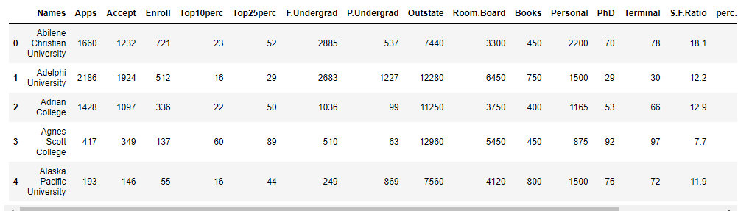
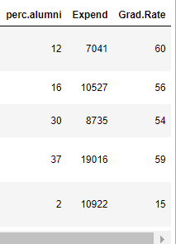
The dataset consists of 18 variables/attributes with 777 entries. It contains information about various colleges with respect to the following attributes.
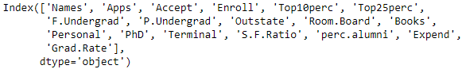
Basic info
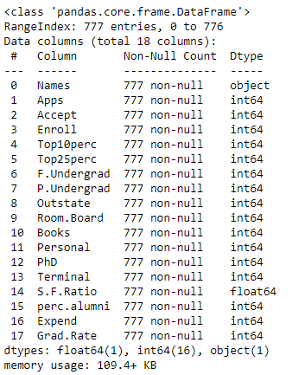
There are 1 object type, 16 integer type and 1 float type attributes. Also, there are no null values.
Description of the columns/attributes present in the dataset:
1) Names: Names of various university and colleges
2) Apps: Number of applications received
3) Accept: Number of applications accepted
4) Enroll: Number of new students enrolled
5) Top10perc: Percentage of new students from top 10% of Higher Secondary class
6) Top25perc: Percentage of new students from top 25% of Higher Secondary class
7) F.Undergrad: Number of full-time undergraduate students
8) P.Undergrad: Number of part-time undergraduate students
9) Outstate: Number of students for whom the particular college or university is Out-of-state tuition
10) Room.Board: Cost of Room and board
11) Books: Estimated book costs for a student
12) Personal: Estimated personal spending for a student
13) PhD: Percentage of faculties with Ph.D.’s
14) Terminal: Percentage of faculties with terminal degree
15) S.F.Ratio: Student/faculty ratio
16) perc.alumni: Percentage of alumni who donate
17) Expend: The Instructional expenditure per student
18) Grad.Rate: Graduation rate
Data Summary (Statistical)
The describe method will help to see how data has been spread for the numerical values. We can clearly see the minimum value, mean values, different percentile values and maximum values.
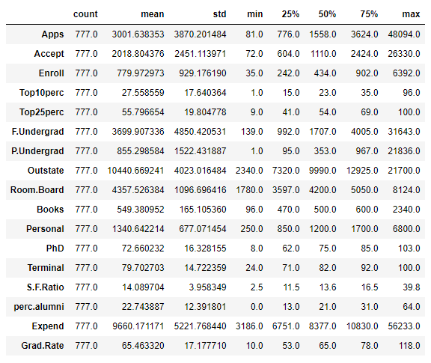
Here, we can observe that the highest number of applications received by a college are 48094 and that of applications accepted is 26330.
The costs of book has gone down to 96 in a college and also the personal expense has gone to as low as 250.
The average student to faculty ratio is 14.089

- Data Pre-processing
Checking for Outliers
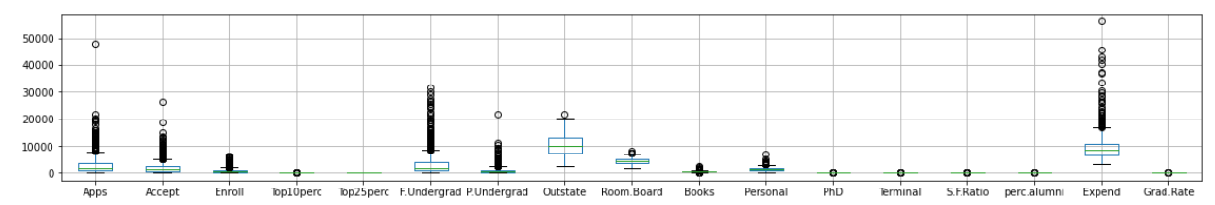
Here, we observe that our data has outliers in almost all variables.
We have not found any duplicates or missing values in our dataset.

UNIVARIATE ANALYSIS
Plotting the frequency plot (histogram) and box plot of individual variables present in the information provided for the colleges.
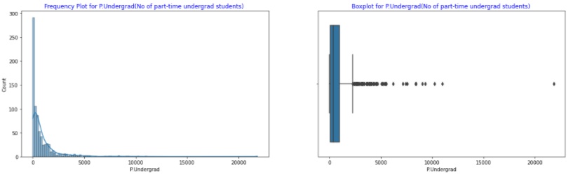
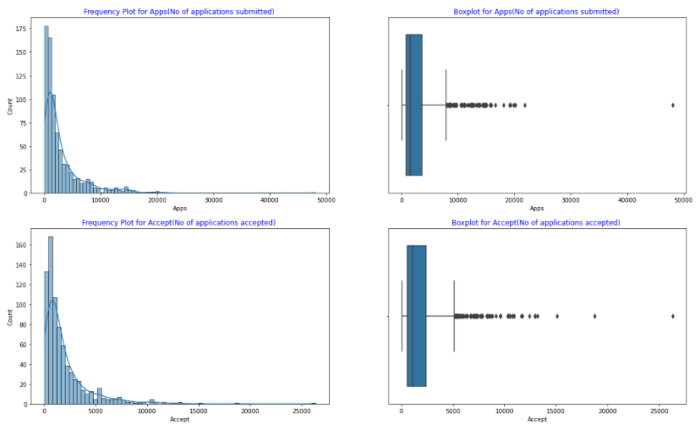
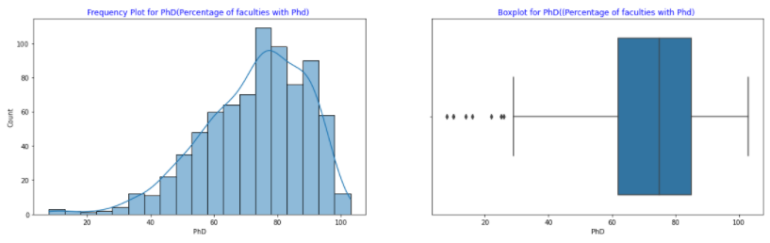
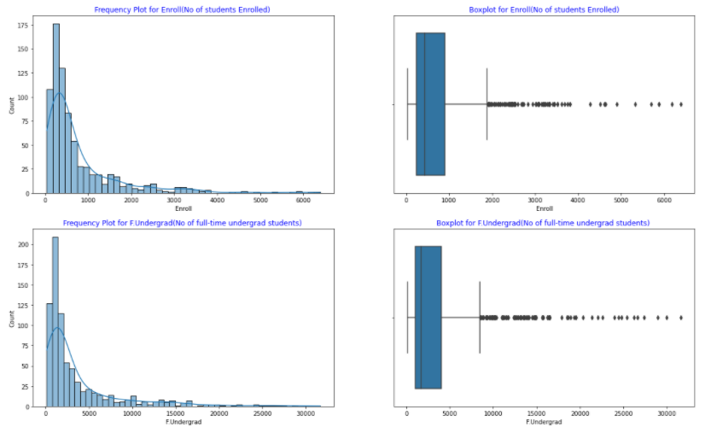

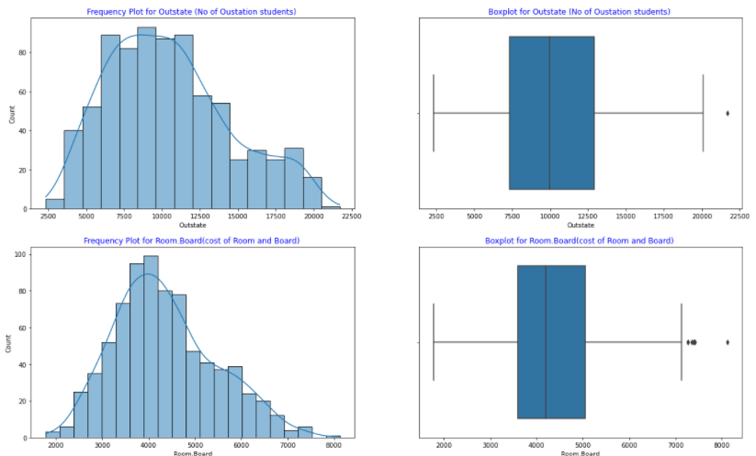
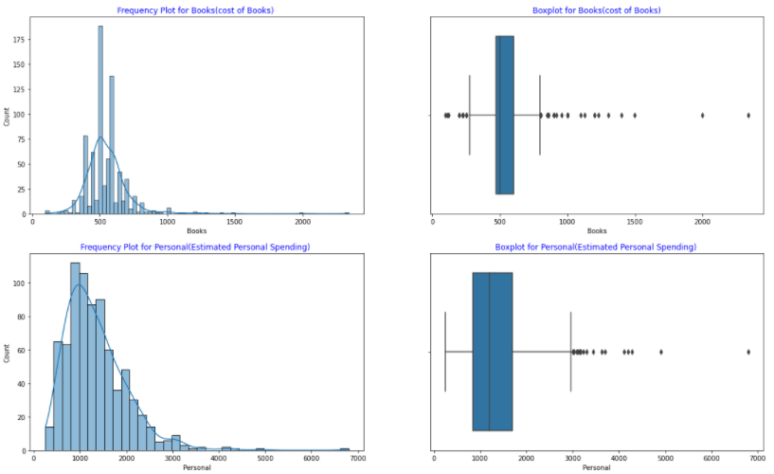
The above graphs are for all the numerical variables in the dataset.
Also, there are no categorical variables.
BIVARIATE ANALYSIS
- Pair Plot (detailed plot can be viewed in the jupyter file)
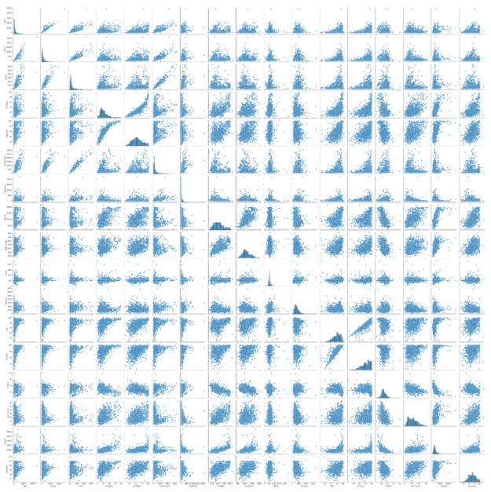
In the above plot scatter diagrams are plotted for all the numerical columns in the dataset. A scatter plot is a visual representation of the degree of correlation between any two columns.
- Correlation Matrix (detailed matrix can be viewed in the jupyter file)
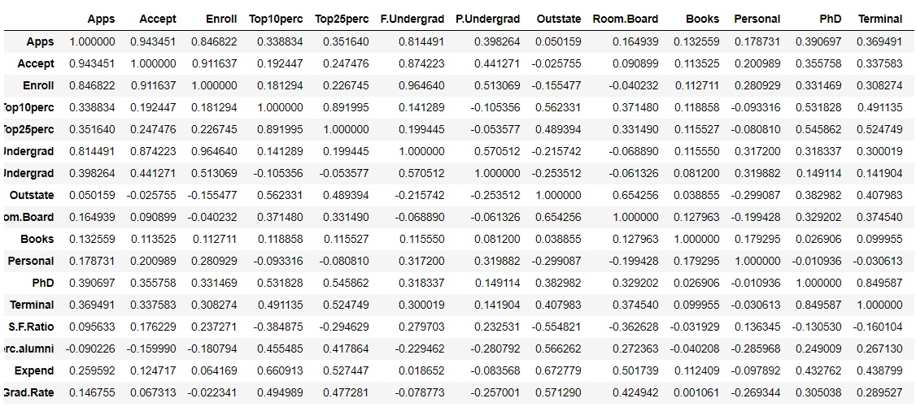
- Correlation/Heat Map
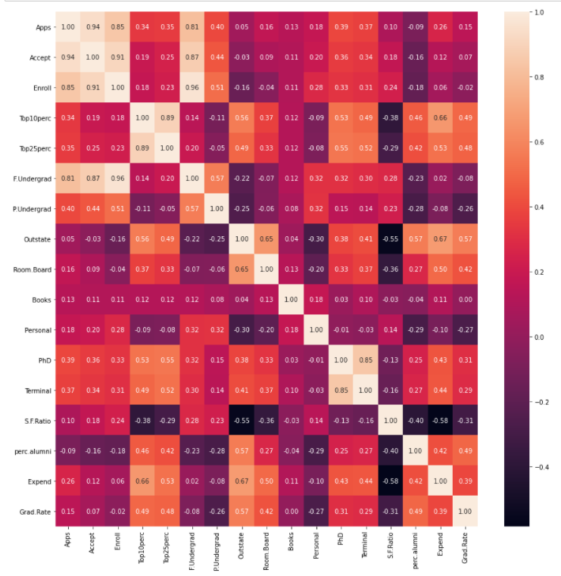
The above correlation matrix and the corresponding heat map shows how all the variables are correlated to each other and to what extent.
We can observe that, number of applications received is highly related to accepted, enrolled and number of full time graduate students. Other attributes does not show a high correlation with each other and seem to have independent importance.
Insights
- The data is numeric in nature and consists of statistical data of various colleges.
- The highest number of applications received by a college are 48094 and that of applications accepted is 26330
- Considering all colleges, the average student to faculty ratio is 14.089
- The costs of book has gone down to 96 in a college and also the personal expense has gone to as low as 250.
- All the colleges have at least 8 faculties with PhD degree and minimum 24 faculties with terminal degrees.

Q2. Is scaling necessary for PCA in this case? Give justification and perform scaling.
Often the variables of the data set are of different scales i.e. one variable is in millions and other in only 100. For e.g. in our data set Apps received and accepted is having values in thousands and S/F ratio is in just two digits. Since the data in these variables are of different scales, it is tough to compare these variables.
Feature scaling (also known as data normalization) is the method used to standardize the range of features of data. Since, the range of values of data may vary widely, it becomes a necessary step in data preprocessing while using machine learning algorithms.
In this method, we convert variables with different scales of measurements into a single scale.
Yes, scaling is necessary for PCA in this case, because most of the attributes are numerical with few of them having values in thousands and few having two digit values.
Below is the original data (top 5 rows)
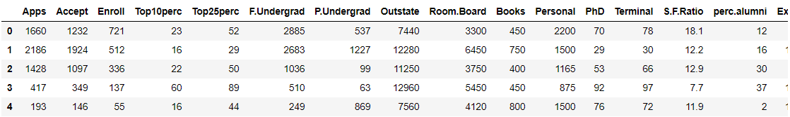

Scaled Data- we have performed scaling by applying z-score value to all numerical variables.
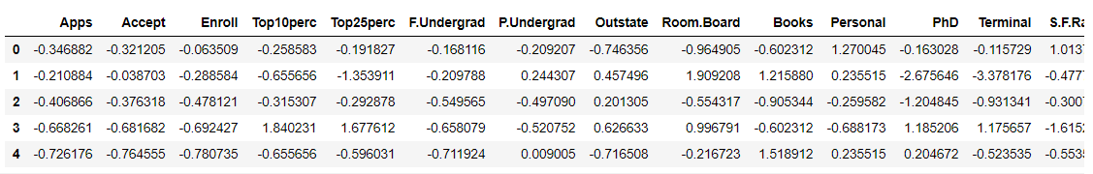
We can see that applications received and accepted had values in thousands and now it has a negative value after applying the z-score.

Q3. Comment on the comparison between the covariance and the correlation matrices from this data.
Covariance Matrix
Covariance is when two variables vary with each other, whereas Correlation is when the change in one variable results in the change in another variable. [1]
The value of covariance between 2 variables is achieved by taking the summation of the product of the differences from the means of the variables as follows:
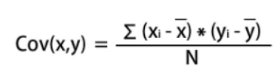
Cov(x,y) is covariance of variables x and y
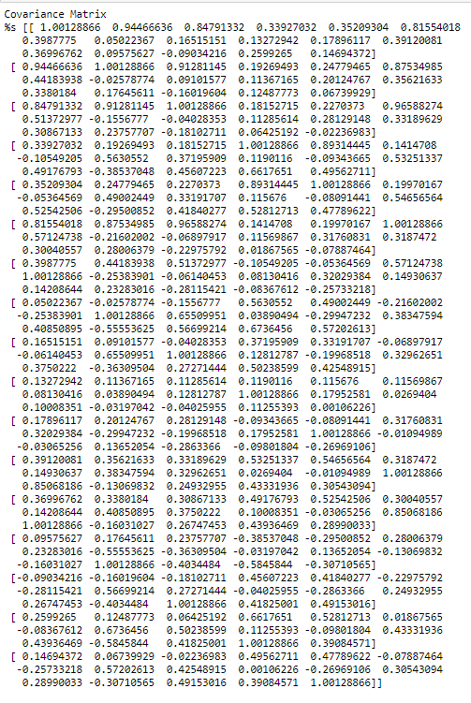
When the two features are positively correlated, the covariance is greater than zero, otherwise, it has a negative value. Furthermore, if there is no evidence of a correlation between them, hence the covariance is equal to zero.
Correlation Matrix
Correlation analysis is a method of statistical evaluation used to study the strength of a relationship between two, numerically measured, continuous variables.
We can say the correlation values have standardized notions, whereas the covariance values are not standardized and cannot be used to compare how strong or weak the relationship is because the magnitude has no direct significance. [1]
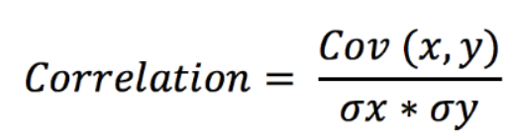
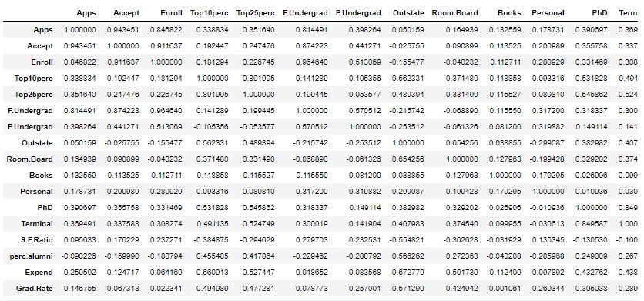
From the above two matrices, we can say that the covariance and correlation matrices are both approximately similar with slight differences in decimal values.
Q4. Check the dataset for outliers before and after scaling. What insight do you derive here?
Original dataset
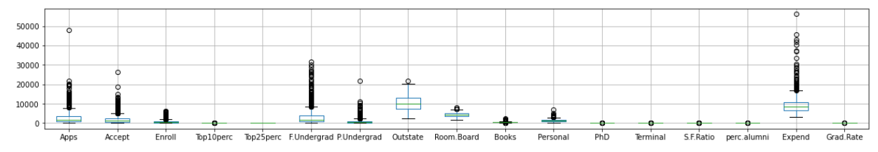
Scaled Dataset
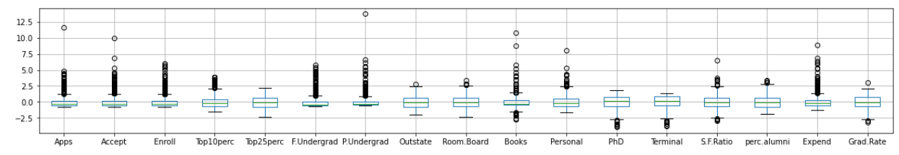
Insights
- Here, we observe that the outliers have increased after scaling.
- Most of the data has centered their spread around zero value after scaling
- Many variables like books have increased number of outlier points after scaling has been performed.
Q5. Perform PCA and export the data of the Principal Component scores into a data frame.
Step 1: Create covariance matrix (displayed in Problem 2, Q3 above)
Step 2: Perform Eigen decomposition, that is, compute Eigen vectors which are the principal components and the corresponding Eigen values which are the magnitudes of variance captured.
These are the Eigen vectors (refer to Jupyter file to get complete Eigen vectors)
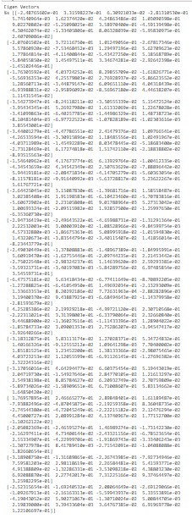
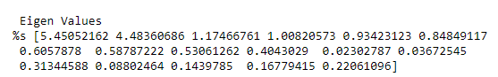
Step 3: Scree Plot
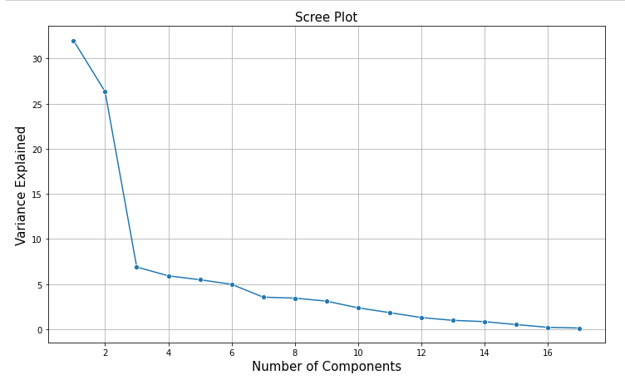
Scree plot is a line plot of the eigenvalues of factors or principal components in an analysis. The scree plot is used to determine the number of factors to retain in an exploratory factor analysis (FA) or principal components to keep in a principal component analysis (PCA).
In the above Scree plot, we observe that there is a distinct break near 2. However, 𝑘 (no. of PC to be considered for analysis) cannot be taken to be 2 since the first two PCs explain only 58% of total variance. The PCs must be taken so as to explain between 70% - 90% of the total variance. If 𝑘 = 7, then the first 7 PCs explain 85% of the total variance. One choice of 𝑘 could have been 7. However, we have taken 𝑘 = 9 so that the explained variance is above 90%.
Step 4: Extracting the Principal components and then showing them after loading into a dataframe.
Principal Component Analysis, or PCA, is a dimensionality-reduction method that is often used to reduce the dimensionality of large data sets, by transforming a large set of variables into a smaller one that still contains most of the information in the large set.
PCA is defined as an orthogonal linear transformation that transforms the data to a new coordinate system such that the greatest variance by some scalar projection of the data comes to lie on the first coordinate (called the first principal component), the second greatest variance on the second coordinate, and so on. [2]

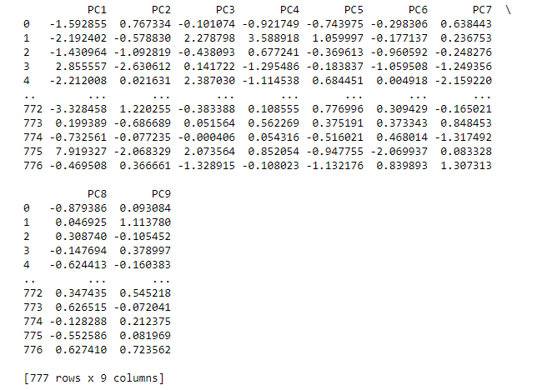
The above dataframe shows 9 principal components.

Q6. Extract the eigenvalues and eigenvectors. [Print both]
Eigenvectors are the directions along which a particular linear transformation acts by flipping, compressing or stretching. Eigenvalue can be referred to as the strength of the transformation in the direction of eigenvector or the factor by which the compression occurs.
The Eigen Vectors are as follows:

Q7. Write down the explicit form of the first PC (in terms of the eigenvectors. Use values with two places of decimals only).
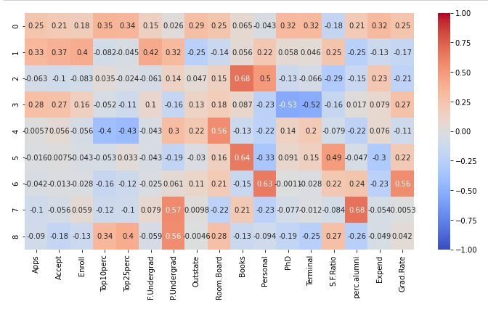
The above map shows the amount of data each principal component contains in terms of different attributes.
The explicit form of first PC in terms of Eigen vectors can be written as below:
Q8. Consider the cumulative values of the eigenvalues. How does it help you to decide on the optimum number of principal components? What do the eigenvectors indicate?
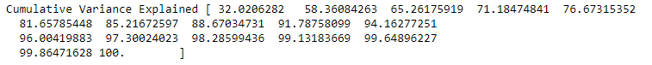
In the above Scree plot, we observe that there is a distinct break near 2. However, 𝑘 (no. of PC to be considered for analysis) cannot be taken to be 2 since the first two PCs explain only 58% of total variance. The PCs must be taken so as to explain between 70% - 90% of the total variance. If 𝑘 = 7, then the first 7 PCs explain 85% of the total variance. One choice of 𝑘 could have been 7. However, we have taken 𝑘 = 9 so that the explained variance is above 90%.
Therefore, cumulative values of the Eigen Values play an important role in deciding the number of principal component which should be considered for analysis.
As here, if we could decide that we should consider at least 9 Principal components as the cover 91% of variance as explained by cumulative values.
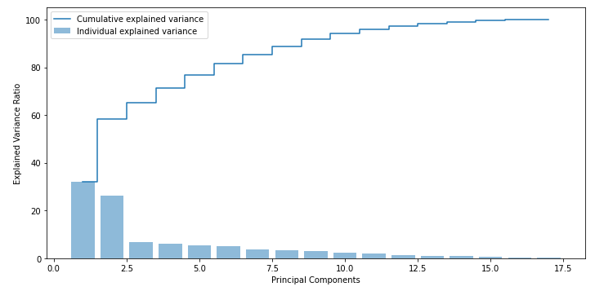
Here from the above plot, Eigen vectors with insignificant contribution to total Eigen values can be removed from analysis (for e.g. Eigen vector above 10)
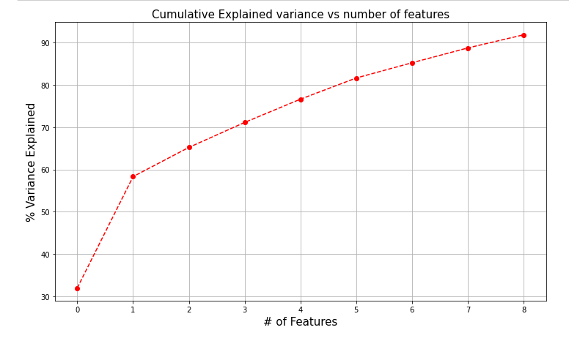
The Eigen vectors are the corresponding vectors of the principal components which are used for analysis.
The main principal component is the first Eigenvector. The second Eigenvector will be perpendicular or orthogonal to the first one. The reason the two Eigenvectors are orthogonal to each other is because the Eigenvectors should be able to span the whole x-y area.
Q9. Explain the business implication of using the Principal Component Analysis for this case study. How may PCs help in the further analysis? [Hint: Write Interpretations of the Principal Components Obtained]
- With help of PCA we have been able to reduce 17 numeric features into 9 components which is able to explain 91% of variance in the data
- We have used PCA for this analysis as we had 17 attributes of numerical type and it was difficult to analyze which is most important and least important variable for drawing any insights or observing patterns.
- Principal Component 1 contains maximum data.
- PC2 consists of the other important data which can be used for analysis like applications received, submitted, students enrolled, no. of full time graduates, personal expense and s/f ratio.
- The Eigen vectors 1 and 2 has the most importance and Eigen vectors with insignificant contribution to total Eigen values can be removed from analysis.(E.g.-values above 9)
- Unsupervised learning like clustering can further be applied on the data to segment the customers based on the components created and further analyzed.

Thank You!!

References
[1] https://www.mygreatlearning.com/blog/covariance-vs-correlation/
[2]Wikipedia

